What is a cache line?
A cache is a unit of memory that is built in the CPU. The most modern CPU´s have 3 cache levels.
L1, L2 and L3.
L1 is the fastest and L3 is the slowest. Each cache level has several cache lines. (The RAM does not have any cache lines.)
section .data
num_1 dq 1234
section .text
mov rax, [num_1]
The CPU checks if the data can be found in any cache level. This process is called: cache lookup. It starts with L1 because that is the fastest cache level. If it can´t find the data in L1 then it looks in L2 and finally in L3. If the data cant be found in any cache level then it will fetch the data from RAM.
After fetching the data from RAM it caches the data in a cache line at a given cache level. That is useful because when the CPU needs to access the data again then it can find the data in a cache line and does not need to look again in the RAM.
The CPU fetches the data always in 64 byte chunks even when less data is required. That counts from the RAM and also for the cache lines.
(If the CPU finds the data in any cache level then it´s a cache hit and otherwise a it´s a cache miss. After a cache miss the CPU looks for the data in RAM).

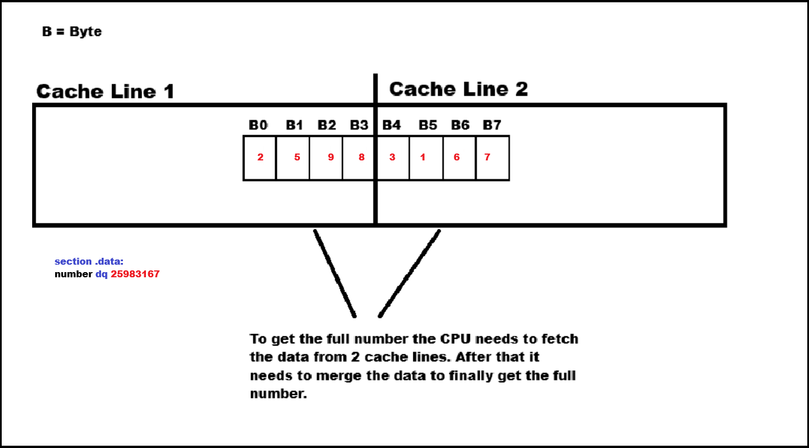
The CPU needs to fetch data from 2 cache lines and that is then called a cache line split penalty.

However cache line splits are only a problem when the code gets executed many times. For example in a loop. Otherwise a cache line split pentalty is not a big deal. Its also not guaranteed that a cache line split pentalty occurs.
How to align the memory addresses to share the data in a single cache line
section .data:
align 16 ; With align 16 we can make sure that the first memory address (variable) is 16 byte aligned
number_1 dq 56131461
number_2 dq 87437823

section .text:
mov rcx, [number_1]
mov rdx, [number_2]

number_1 is guaranteed to be 16 byte aligned and under normal linker (Linker exaplained in one sentence: NASM creates a object file and the linker combines the object file with a .lib file and then it creates a .exe file.) behavior number_2 will then be aligned by 8 byte.

Address alignment can be forced with the align macro. The number for the alignment needs to be a power of 2.
Addresses for a 16 byte alignment:
0, 16, 32, 64
This is how it looks like in our example:
0, 16 (number_1), 24 (number_2), 32, 40, 48, 56, 64
(number_1 could also start at address 56 and number_2 at address 64)
The variables are in consective order. This is also called spatial locality. The CPU can now easily load all the data at once.

Let´s assume that the data is still not in any cache line:
mov rcx, [number_1]
The CPU needs to fetch the data now from RAM (it fetches always 64 byte). Since our data is aligned to share a cache line. The CPU needs only one memory fetch to copy the values into a cache line.

mov rcx, [number_2]
The CPU can now immiately load the data from a cache line. It does not need to look into the RAM again.

When we should align memory addresses

If we execute any SSE/AVX instruction that requires memory alignment.

Here are some instructions that require 16 byte memory address alignment:
movaps, movapd, movdqa, vmovaps, vmovapd, movdqa.
And these instructions require 32 byte memory address alignment:
vmovaps, vmodqa64

But there are more instructions just check the offical documentations from Intel or AMD.

Instead of using vmovapd we could also use an instruction like vmovupd. The vmovupd instruction works without aligned memory addresses.

There is not difference in terms of speed between vmovapd or vmovupd when the memory addresses are aligned. However if we use vmovupd and the memory address is not aligned then this can lead to a cache line split penatly.

Guaranteed memory alignment:
If we need to write any code that needs to guarantee memory alignment then its better to use vmovapd. Because a not aligned memory address will then immidately lead to a program crash. While a instruction like vmovupd would be able to keep executing the code but with the disadvantage of the possibility of cache line split penaltys.

Windows x64 calling convention

Before a function call we need to make sure that RSP % 16 = 0. So the address of the RSP needs to be 16 byte aligned.

Page-boundary faults (explain in a other vid)

